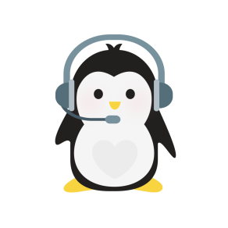
It's only my opinion “This is what you should read next!”
Discussions devoted to promoting reading, to book talking, recommendations for great reads and fun. Let’s chat about books.

Name:
Email:
Three Books that you Loved

One Book that you Hated

The Book that you are Reading now

An interesting topic you’d like to talk about

Day or days you are available to chat

